User Guide 29 Manage Conditions
Purpose of this User Guide
The purpose of this User Guide is to provide information to SPEAR users on how and when to use the ‘Manage conditions’ functionality in SPEAR.
Who should read this?
Primary audience: Responsible Authority, Applicants, referral authorities
Introduction
The Manage Conditions document allows Responsible Authority users to create conditions that need to be met prior to certification and/or Statement of Compliance (SOC).
Use of this functionality will provide the Applicant Contact, referral authorities and guests with information about which conditions are outstanding and give those users the ability to provide comments and/or evidence of completion of conditions.
The Manage Conditions document is available to the Responsible Authority as an optional action once the status of the application reaches ‘Lodged with Responsible Authority’. Responsible Authorities can add conditions to an application by selecting them from a set of standard conditions maintained by their Local Administrator, or by copying conditions from a previous application, or by manually entering them into the application directly.
If conditions are outstanding, SPEAR will not allow the application to progress to the relevant certification or SOC decision. The SPEAR application status will also be amended to indicate to all users that there are conditions outstanding e.g. ‘Certification Decision Pending (Outstanding Conditions).’
This function is designed to facilitate communication between all stakeholders regarding outstanding conditions by providing Responsible Authorities the opportunity to create and maintain a list of conditions, which the other key stakeholder groups can access and provide comment on.

29.1 How does the Responsible Authority create a ‘Conditions’ document?
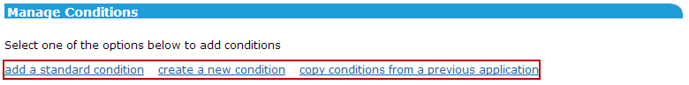
Once the status of the application reaches ‘Lodged with Responsible Authority’ the optional action ‘Manage Conditions’ becomes available to the Responsible Authority through the ‘Other Actions’ drop-down list.
Conditions can be entered by selecting one of the three options:

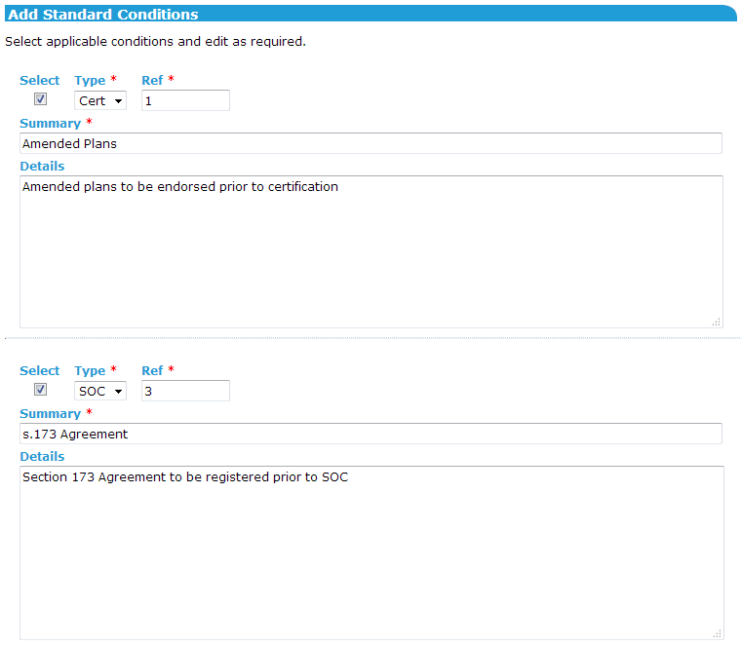
- Add a standard condition
The user is presented with a list of standard conditions previously created by the Local Administrator. The relevant conditions can be amended if required, before being added.

- Create a new condition
The user is presented with a blank conditions field, where they can define the type of condition, a summary of the requirement, and the details.
- Copy conditions from a previous application
The user can copy conditions from a previous application by supplying the SPEAR reference number of the previous application.

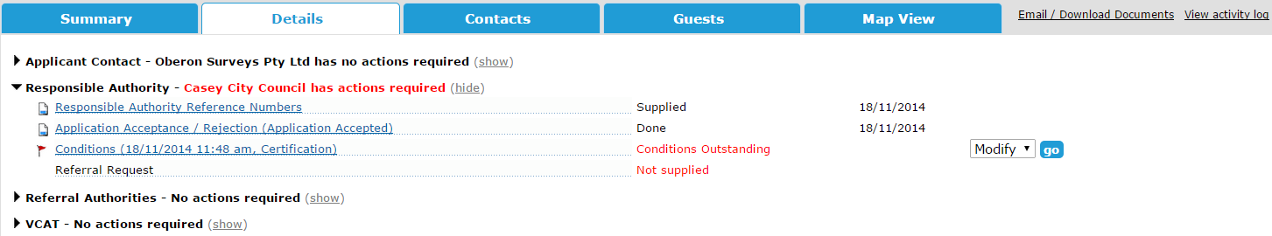
Once activated, the Conditions document is displayed under the Responsible Authority section of the Details screen and is shown with the action suffix of ‘Outstanding Conditions’ until the Responsible Authority confirms all conditions have been met.

The conditions and comment log can be accessed by all users by clicking on the document link from the Responsible Authority section:
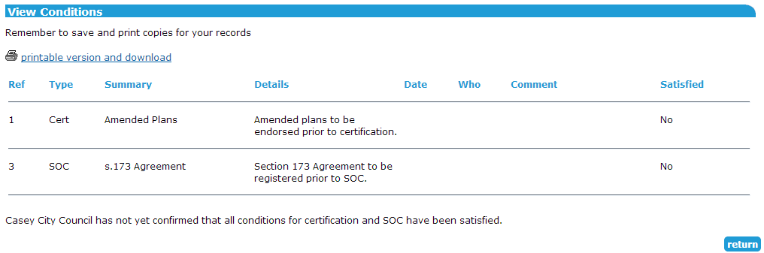

If a Conditions document is instigated or modified by the Responsible Authority, an email is sent to the Applicant Contact and referral authorities prompting them to review the conditions or view the changes.
29.2 How does the Responsible Authority maintain the Conditions document?
Responsible Authority users can modify the document at any time, to reflect updates to the conditions, add new conditions, review comments for each condition, and finally, to indicate that the condition has been satisfied.
To make changes to the document, the Responsible Authority must select the ‘Modify’ option alongside the document on the Details screen. The following features are available from the Manage Conditions screen:
- The table of conditions can be sorted per the column headers (ascending or descending)
- New conditions, or standard conditions can be added to the list
- Comments can be added, and the comment log for each condition can be reviewed by clicking on the details & edit link
- Conditions can be deleted, if no longer required
- Conditions can be confirmed as satisfied, either for certification, Statement of Compliance, or both, by ticking the relevant checkboxes on screen.
NOTE 1: Each individual condition must be satisfied, with a comment added to the log, prior to confirming all conditions are satisfied for the relevant type (Cert/SOC).
NOTE 2: If the Conditions document is the only reason why a certification or SOC decision cannot be made, then once all conditions have been satisfied, the ‘Outstanding Conditions’ suffix will be removed from the application status and a mandatory action to make a certification/SOC decision will appear for the Responsible Authority.

29.3 What functionality is available to the Applicant Contact, referral authority or guest?
Once the Conditions document has been created by the Responsible Authority, it can be commented on by other SPEAR users, including the Applicant Contact, referral authorities, and guests.
Users can access ‘Manage Conditions’ from the ‘other actions’ drop-down list on the Details screen. The following features are available from the Manage Conditions screen:
- The table of conditions can be sorted per the column headers (ascending or descending)
- Comments can be added, and the comment log for each condition reviewed, by clicking on the details & edit link
NOTE: There is no facility to attach documents to comments. You will need to use the ‘Add Other Document Type’ functionality under ‘Other Actions’ to supply supporting attachments.
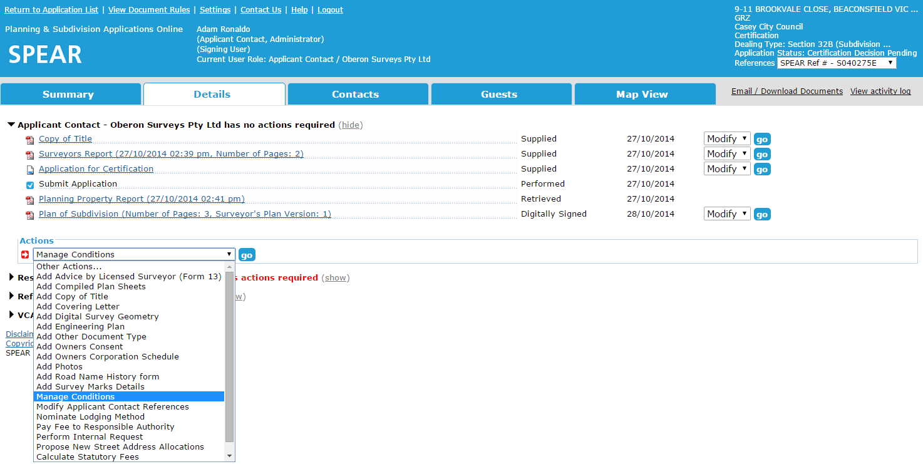
The Responsible Authority will receive an email notification when a comment is added to one or more conditions by another user.

Need more information?
Further information on this topic can be found by:
- Visiting the SPEAR website www.spear.land.vic.gov.au/SPEAR
- Contacting the SPEAR Service Desk on 9194 0612 or email spear.info@delwp.vic.gov.au

